Chapter 12, Problem 84.

Figure 12.76 displays a three-phase delta-connected motor load which is connected to a line voltage of 440 V and draws 4 kVA at a power factor of 72 percent lagging. In addition, a single 1.8 kVAR capacitor is connected between lines a and b, while a 800-W lighting load is connected between line c and neutral. Assuming the abc sequence and taking V_{an} = V_{p} ∠0°, find the magnitude and phase angle of currents I_{a}, I_{b}, I_{c}, and I_{n}.

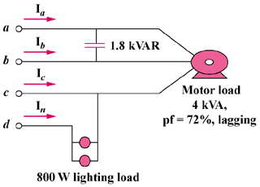

Figure 12.76
For Prob. 12.84.

